



**Define roles & Goals Clearly**

Clarify responsibilities and push for accountability. Encourage people to ask for and offer help in return.



**Say “Yes and”**

Rather than saying “But “and shutting someone down substitute “Yes And” when you reply



**Do not forget about Fun!**

Team Building exercises and games can help build trust, familiarity, and bonding.



**Embrace innovative ideas.**

Help to build rapport by asking for opinions in the first instance.



**Be impactful with your communication.**

Good team communication is not just about talking; it is about connecting, understanding, and acting upon it.

11 Tips

**For**

**Effective Team Communication**



**Always start from a place of 100% trust-**

Assume individuals want to be here and they want to be the best they can be.



**Learn How people Like to Communicate**

Identify team members communication style and how best to communicate with them.

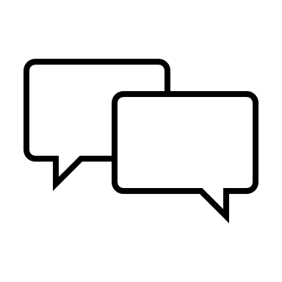

**Embrace 2way communication and Feedback.**

Be Honest and open – Feedback is reciprocal.



**Be Authentic**

It starts with a clear understanding of who you are and for what you stand.



**Explain the WHY**

Help inspire teams (and us) and offer a greater sense purpose.

Be clear on the north star and what are the areas that are the non-negotiable